Name: Rahul Kumar Rajak

**Case Study 14:**

|  |  |
| --- | --- |
|  | 1) Create a collective search help. 2) Include the two Elementary search helps created earlier. 3) Add parameters as shown below. 4) Do the parameter assignment. 5) Test the collective search help. 6) Attach collective search help to DB table field Emp no. Delete any existing search helps. 7) Create entries in DB Table. |

**Solution:**

**Created the collective search help.**

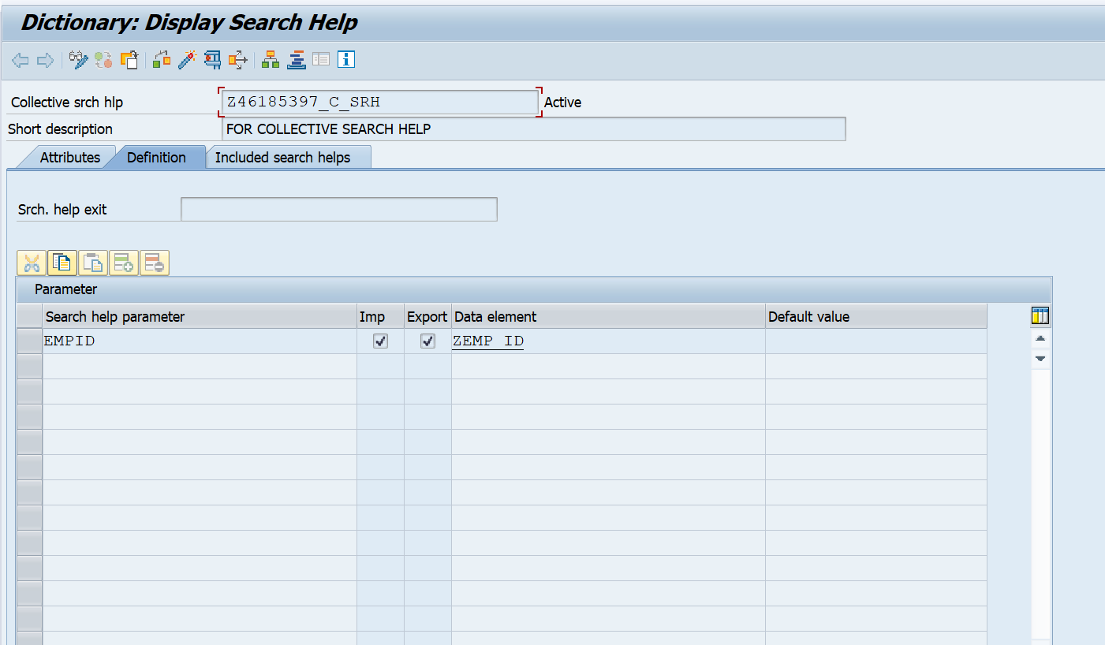

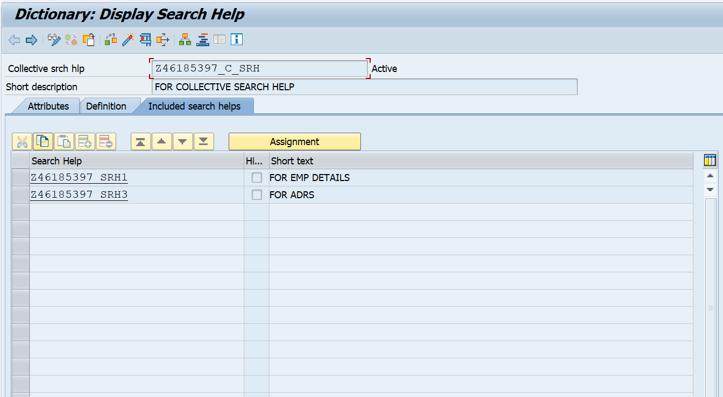**Included the two elementary search help.**

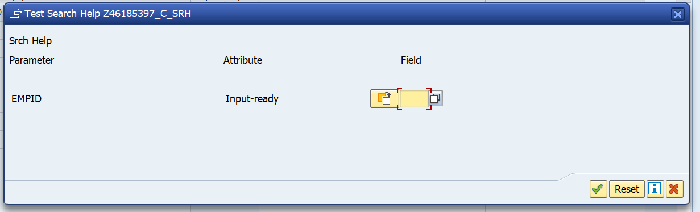**Tested the collective search help.**

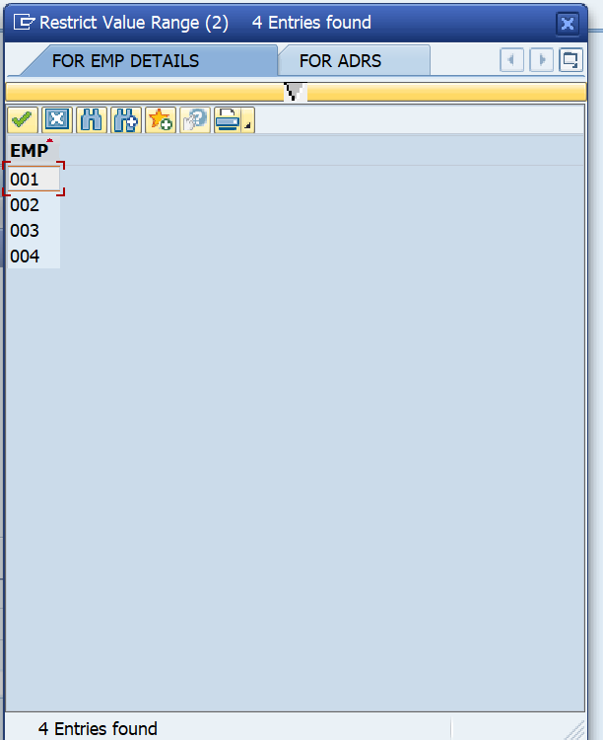

**Attached collective search help to DB table field Empid.**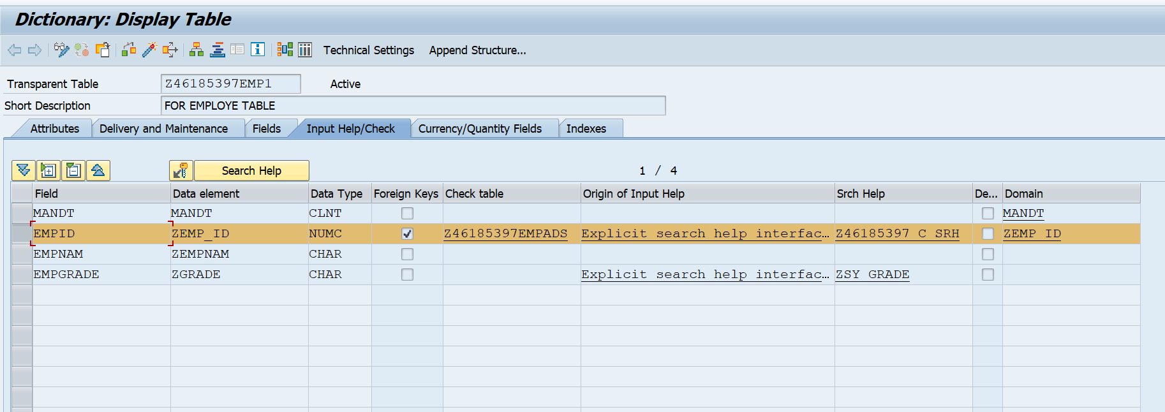

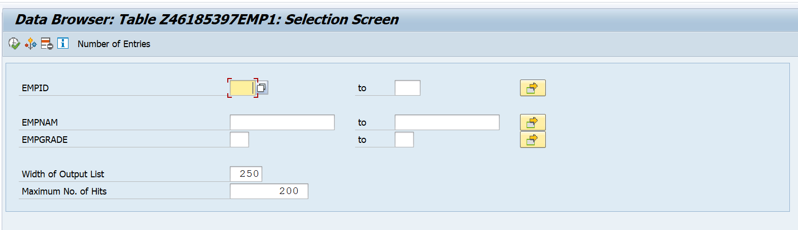**After clicking F4 help in empid.**

**We getting the possible values.**

**Created the entries in DB table.**

